**STUDENT ASSESSMENT SUBMISSION AND DECLARATION**

When submitting evidence for assessment, each student must sign a declaration confirming

that the work is their own.

|  |  |  |
| --- | --- | --- |
| **Student name:abdelkareem yousef mamdoh soubar**  **Student ID:19110022** | | **Assessor name:**  Dr.Aladeen Al Basheer  Dr. Rola Musleh  Ms.Bayan shabanh |
| **Issue date:**  May 25, 2023 | **Submission date:**  June 19, 2023 | **Submitted on:**  **13/6/2023** |
| **Program: Computing** | | |
| **HTU Course Name:** Discrete Maths **BTEC UNIT Title *:** Discrete Maths  **HTU Course Code:** 40303122 **BTEC UNIT Code:** F/618/7429/ Unit 18  **I AM REPEATING THIS UNIT*: (NO)** | | |

# Plagiarism

Plagiarism is a particular form of cheating. Plagiarism must be avoided at all costs and students who break the rules, however innocently, may be penalised. It is your responsibility to ensure that you understand **correct referencing practices**. As a university level student, you are expected to use appropriate references throughout and keep carefully detailed notes of all your sources of materials for material you have used in your work, including any material downloaded from the Internet. Please consult the relevant unit lecturer or your course tutor if you need any further advice.

**Student declaration**

I certify that the assignment submission is entirely my own work and I fully understand the consequences of plagiarism. I understand that making a false declaration is a form of malpractice.

**Student signature:**

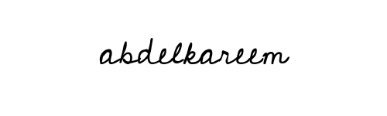

**Date:13/6/2023**